**Assignment – 4**

**(Updating and Deleting the data)**

Write SQL command for the following:

1. Create table book(bid, book_name, writer, publisher, price, genre) with the following constraints:
   1. bid needs to be primary key,
   2. Filling book name and price is mandatory.
   3. Book’s cost should be more than 100 and less than 1000.
   4. If writer name is not available then make the column value unknown by default.

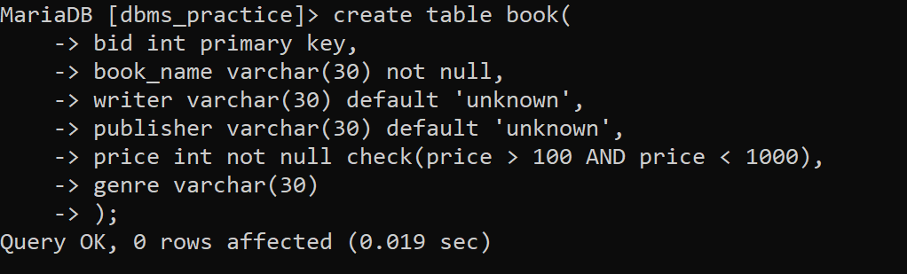

1. Populate the table with 10 tuples.

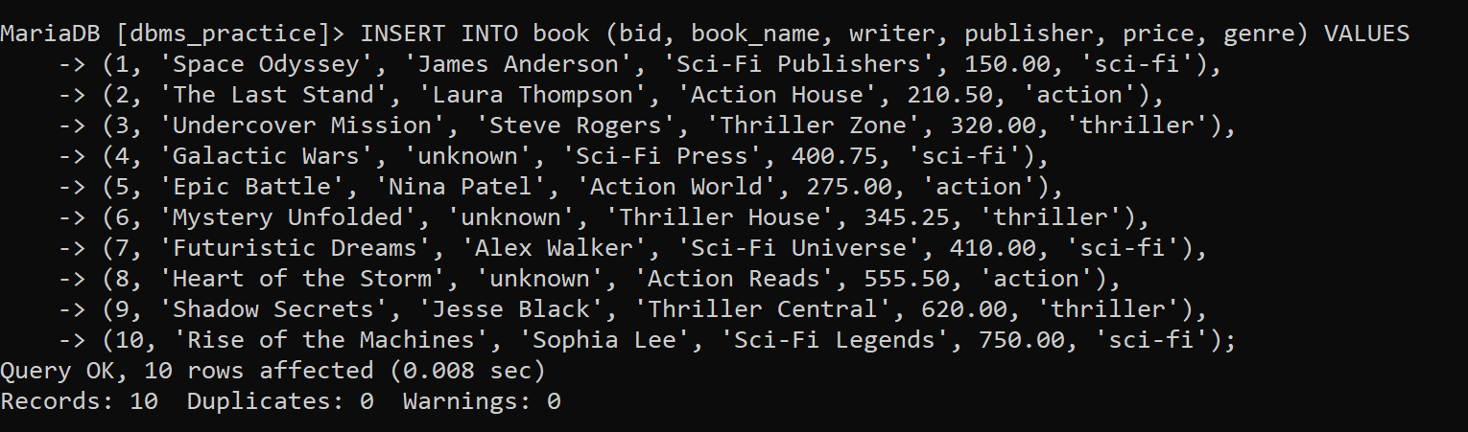

1. Display all the books details.

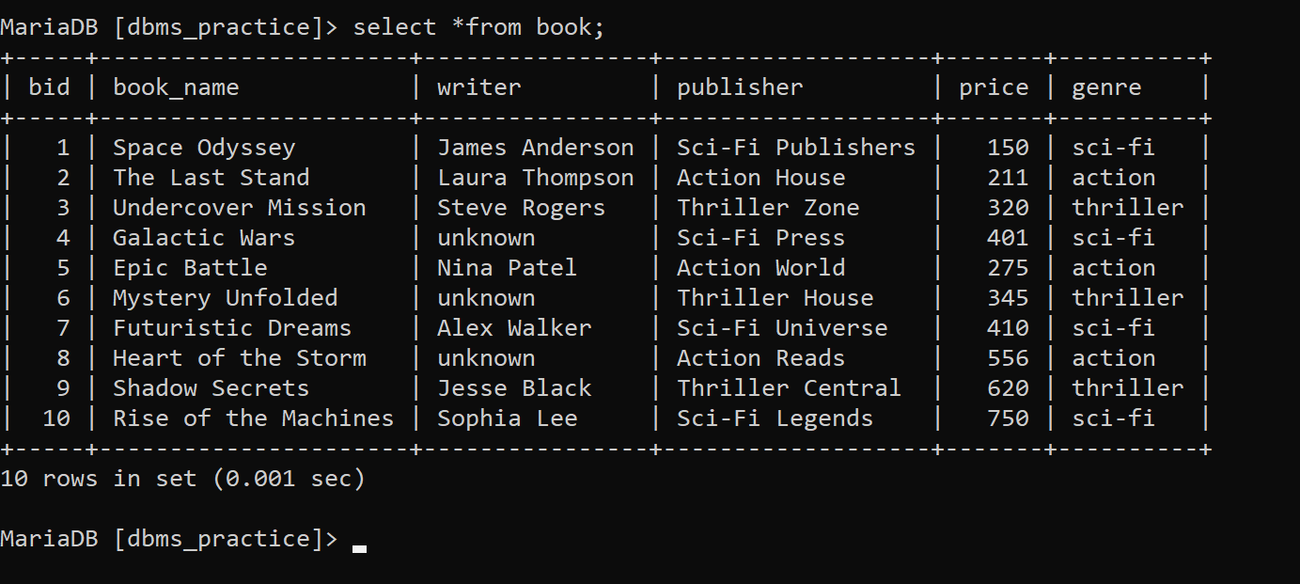

1. Update the genre of any two books.

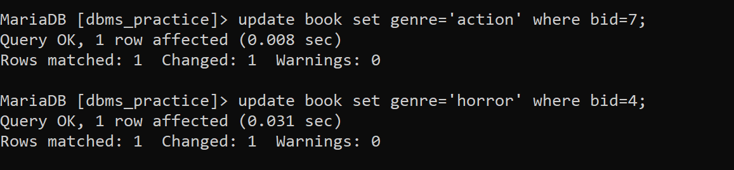

1. Delete the books written by Alex Walker.



1. Display the books name with its writer whose price is more than 500.

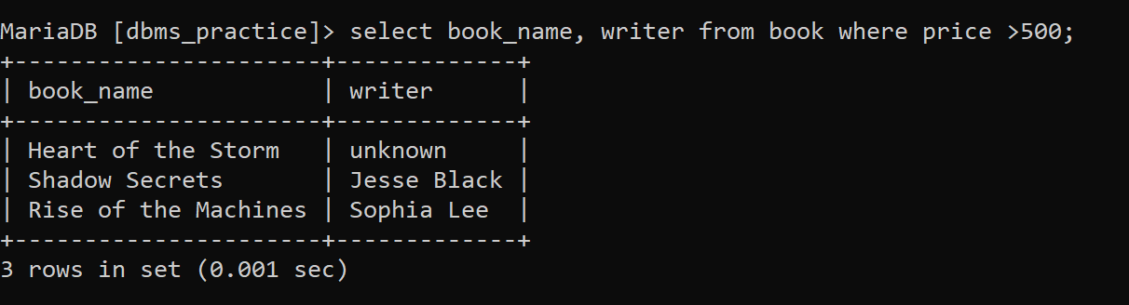

1. Display the books name with its writer whose price is less than 300 and genre is thriller.

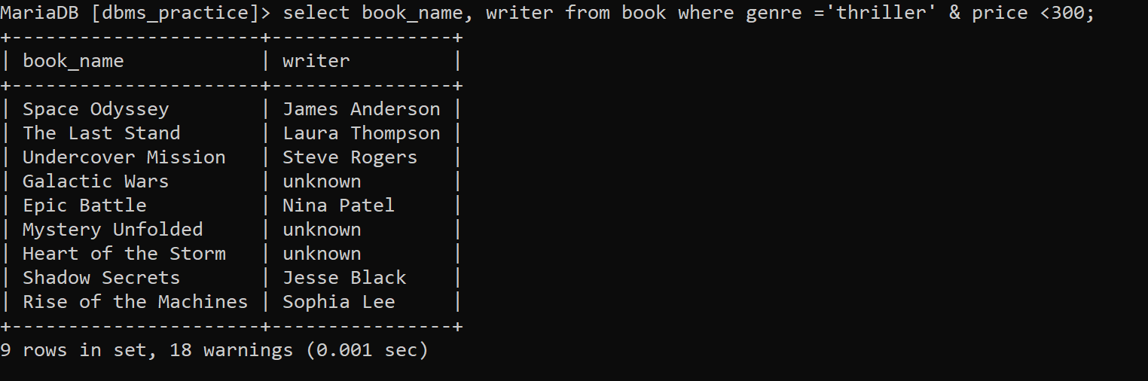

1. Display the name of the books whose writer are unknown.

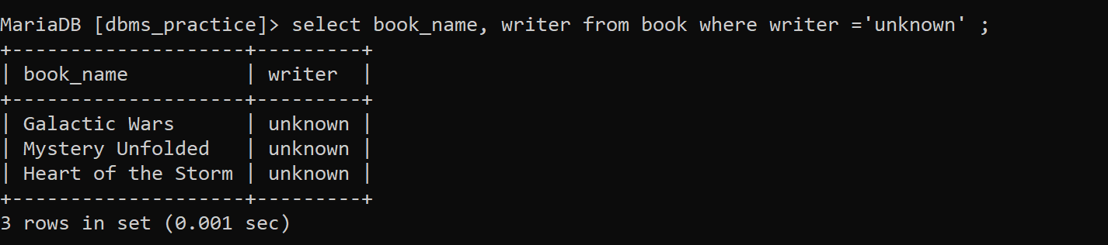

1. Change the book price to exactly 412 if the book publisher is unknown.

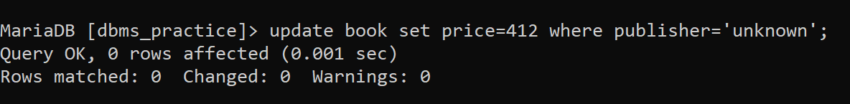

1. Delete the books details whose writer is Shyam and price is more than 300.

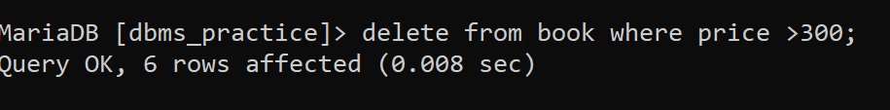

**Note:**

Refer the syntax for Update and Delete Command:

* DELETE FROM table_name WHERE condition;
* UPDATE table_name SET column_name= value WHERE condition;